Lab 2

Nikita Dhingra

# Table of Contents

Table of Contents 2

Lab 2 3

Description 3

Preparation 3

Observations 3

Screenshots 5

Reflection 22

# Lab 2

## Description

This lab assignment includes six tasks that will deploy another application on an AWS Linux machine, installation of prerequisites, building a new database, and connection of the Hospital application which was created in the lab activity 1.

## Preparation

Following the document provided to us and following the steps given in the document.

## Observations

I personally observed that there was a very unexpected error for me, Apache was running smoothly still I was not able to proceed further due to Apache error. So, I started the installation again and did till task 3 again then I was able to the rest of the assignment.

Also I observed the public IP address of the EC2 instance keeps on changing so while connecting to the filezilla we needed to change the IP address while connecting.

Question and Answers:

Q1)Define what this Key Pair is and what it do and used for?

Answer: In AWS, a key pair is a set of two cryptographic keys that are used for authentication and secure communication. It is made up of a key that is private and a key that is publicly accessible. Public Key: A file that can be readily shared to others is the public key. While the data which has been encrypted with the associated public key is decrypted using the private key which is proctected and secured , also must not be shared with anyone else. Key pairs offer a simpler and safe way to authenticate with AWS instances.

Q2) What is purpose of generating privatekey?

Answer: Given that it is needed for important processes like authentication and encryption private key needs to be securely protect and kept securely. The private key's owner may confirm their identity using the private key during authentication. The data which has been encrypted with the associated public key is decrypted using the private key which is protected and secured.

Q3) What is sudo used for?

Answer: Sudo stands for "superuser do" and is used to run commands with special privileges as the root user. The "/etc" directory, for instance, contains a number of system configuration files that can only be changed by the root user , while the installation and deleting of the particular applications can be done by the SUDO.

Q4) Confirm at which step you are able to access the apache

Answer: While changing the security group , I was able to access the apache.

Q5) Show that changes you have done in the inbound or outbound rules for apache to work.

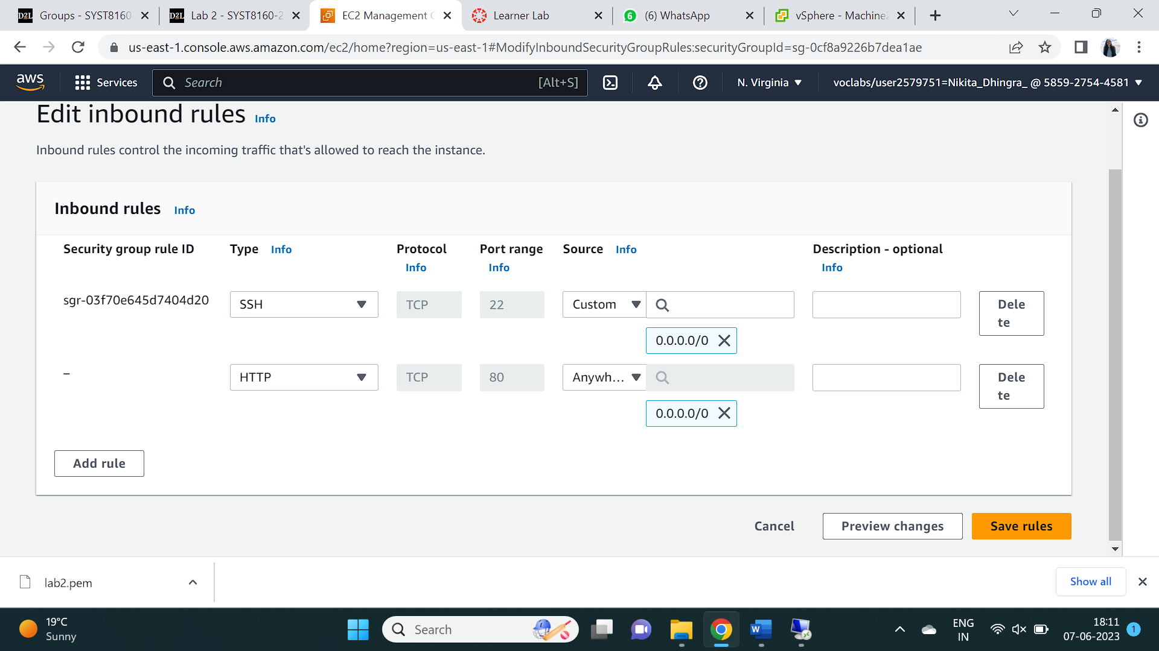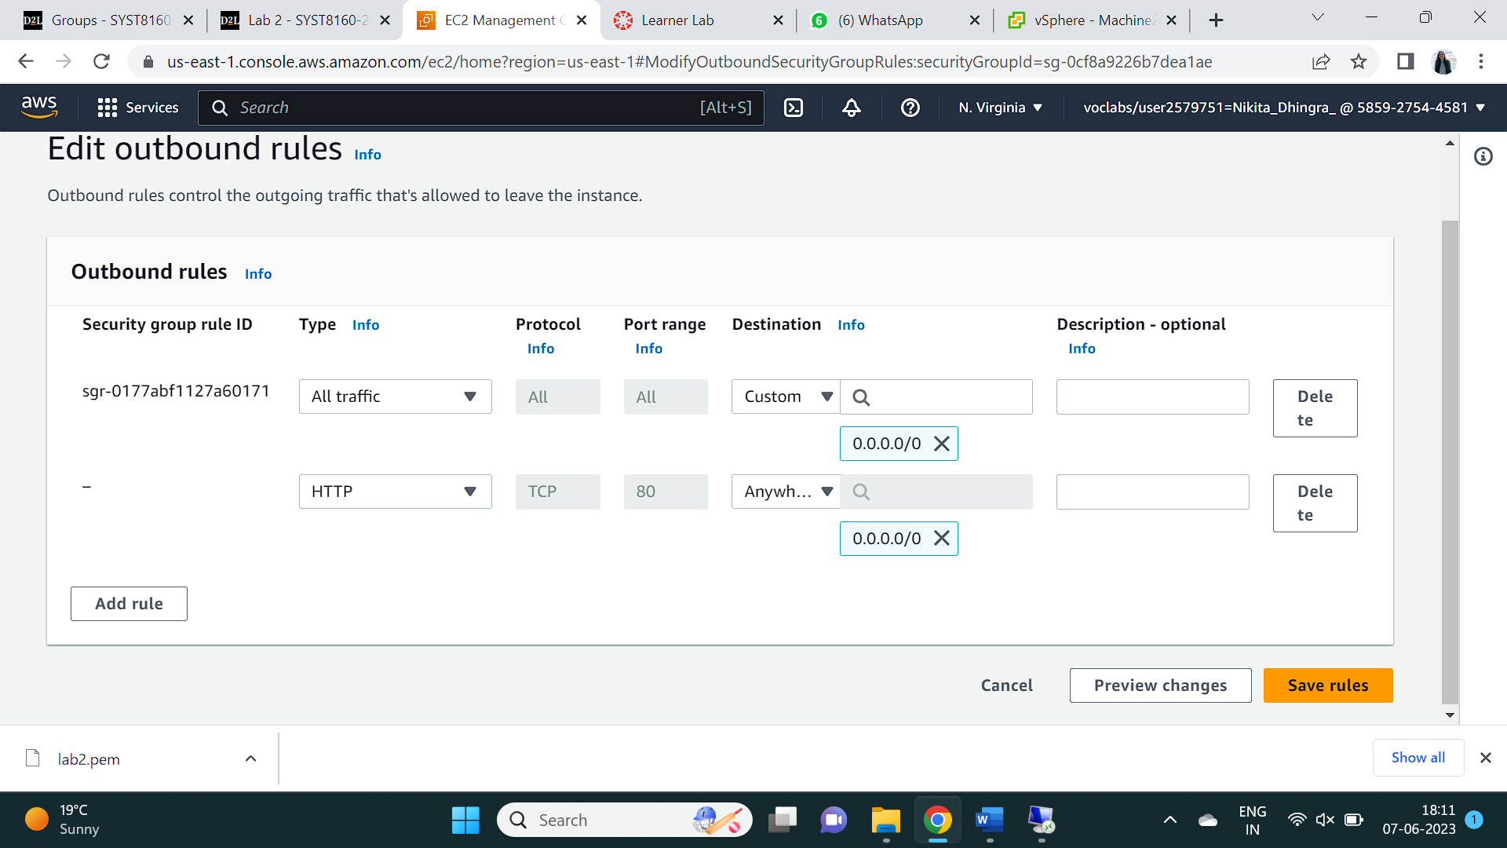

Q6) Explain the purpose of all the re-requisites we installed above? One by one

We can change and redirect URLs by turning on URL rewriting in Apache by installing mod rewrite and shifting the 000-default.conf file. PHP applications may connect to MySQL databases and modify data more easily by using the MySQL extension for PHP, which enables PHP scripts to establish relationships with MySQL databases.

Q7) Which connection string and query is showing the data in the above screen shot? (Point the connection string and query)

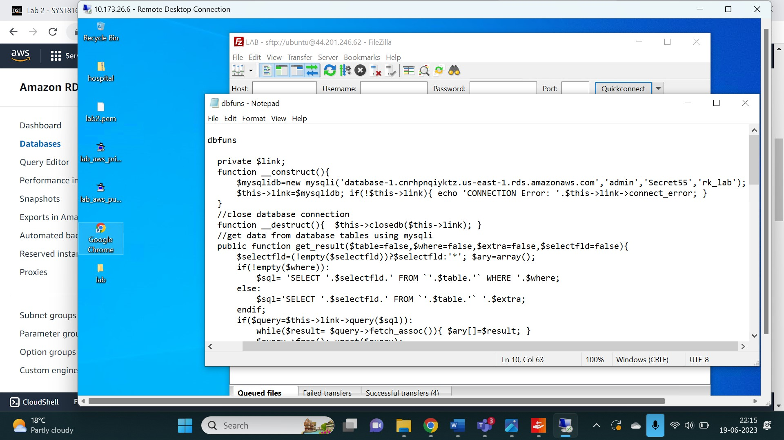

## Screenshots

Task 1: Creation of a Instance on AWS

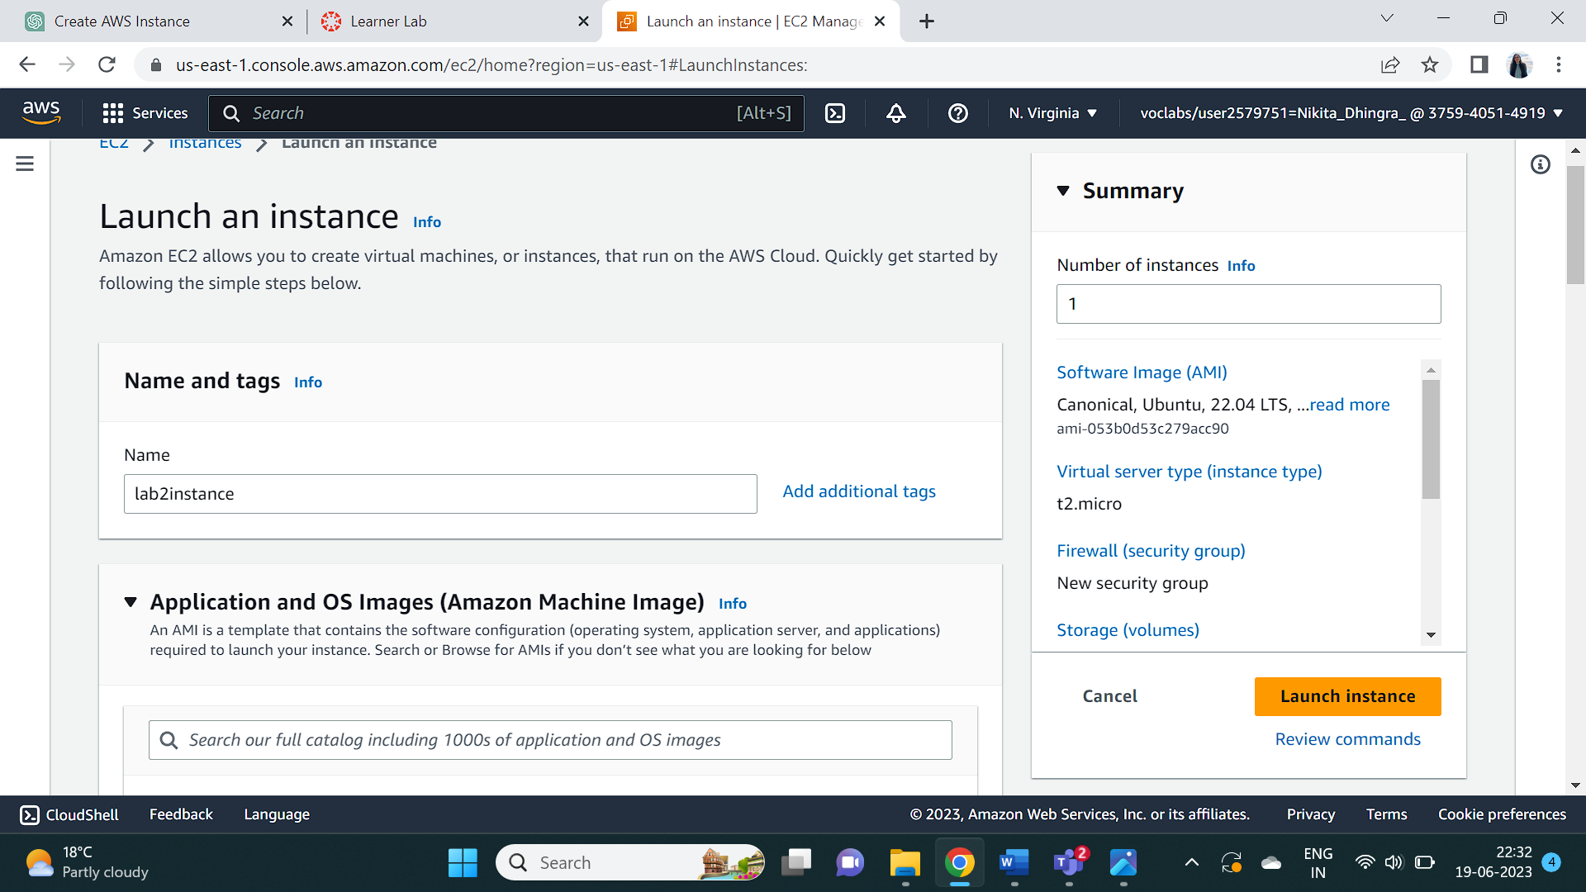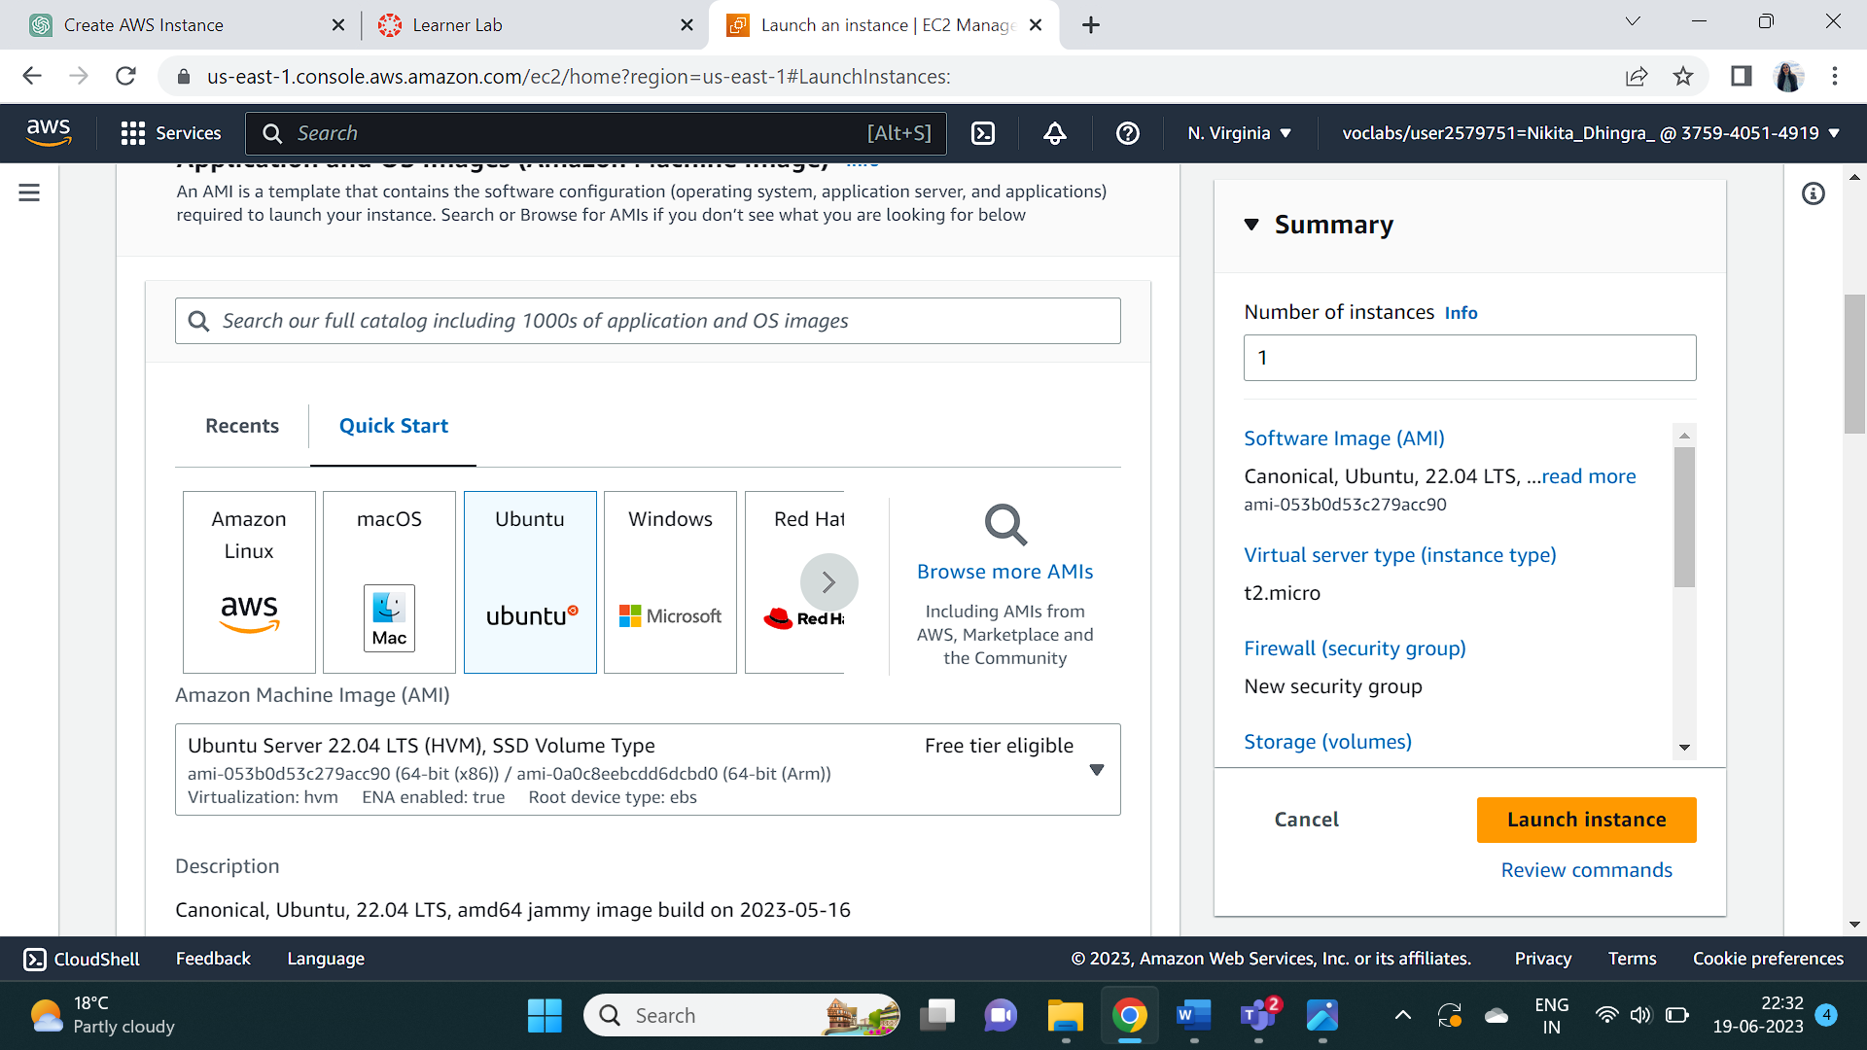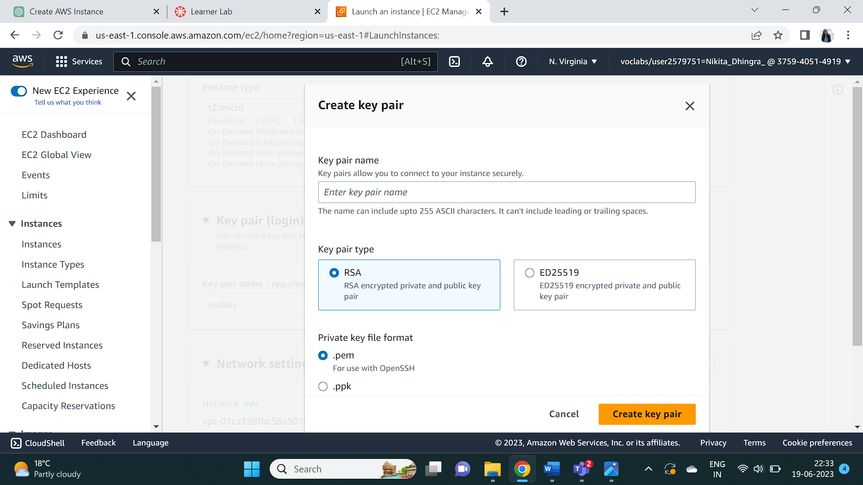

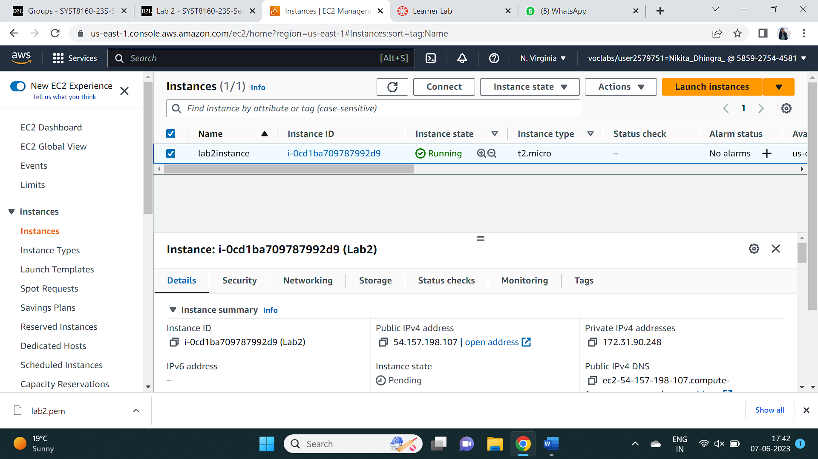

Task 2 : Installing and configuring the Putty to ssh into the AWS machine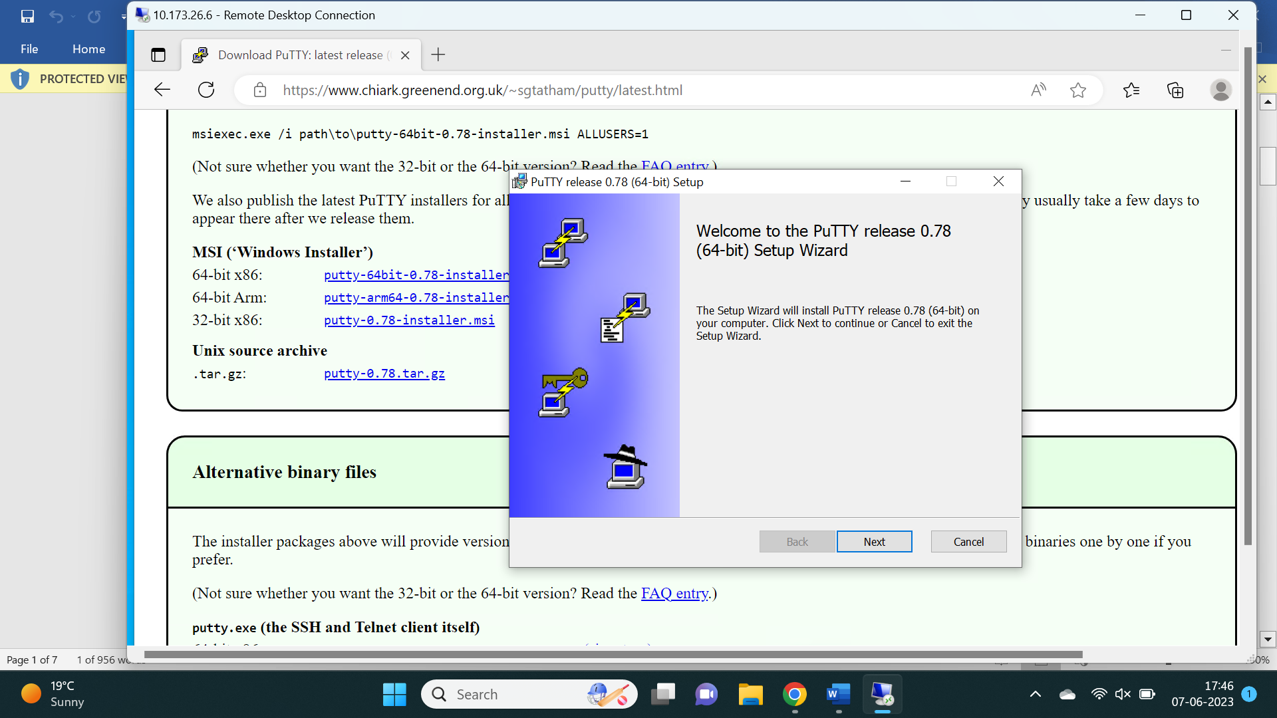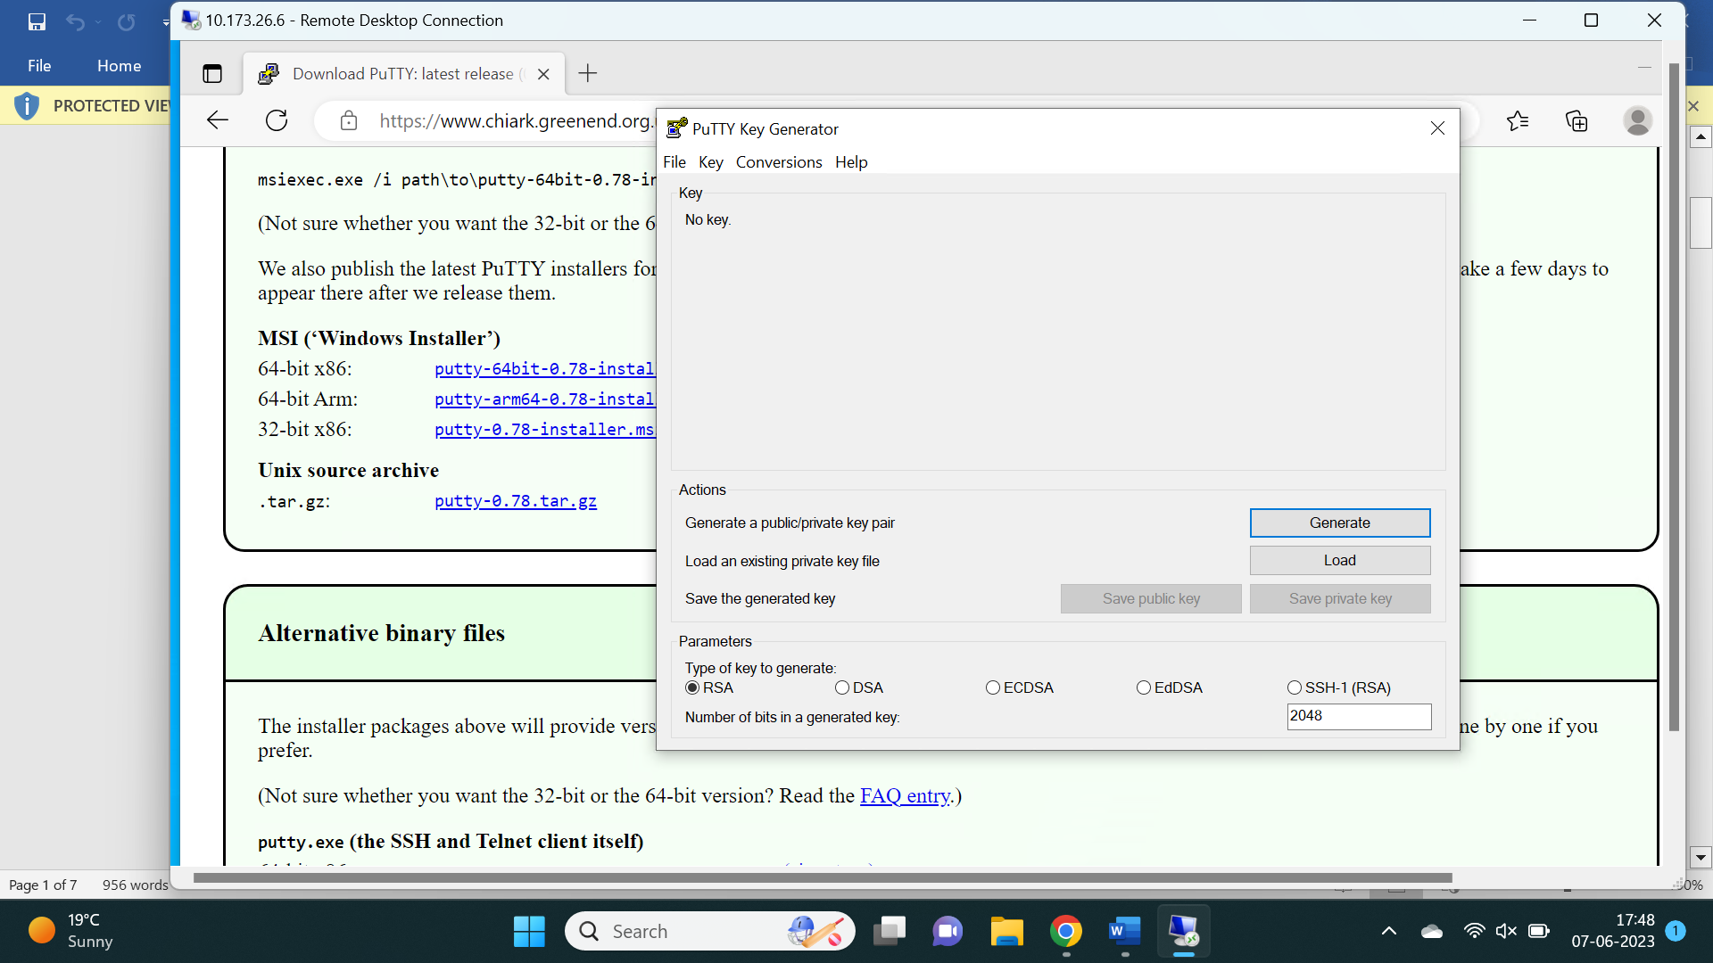 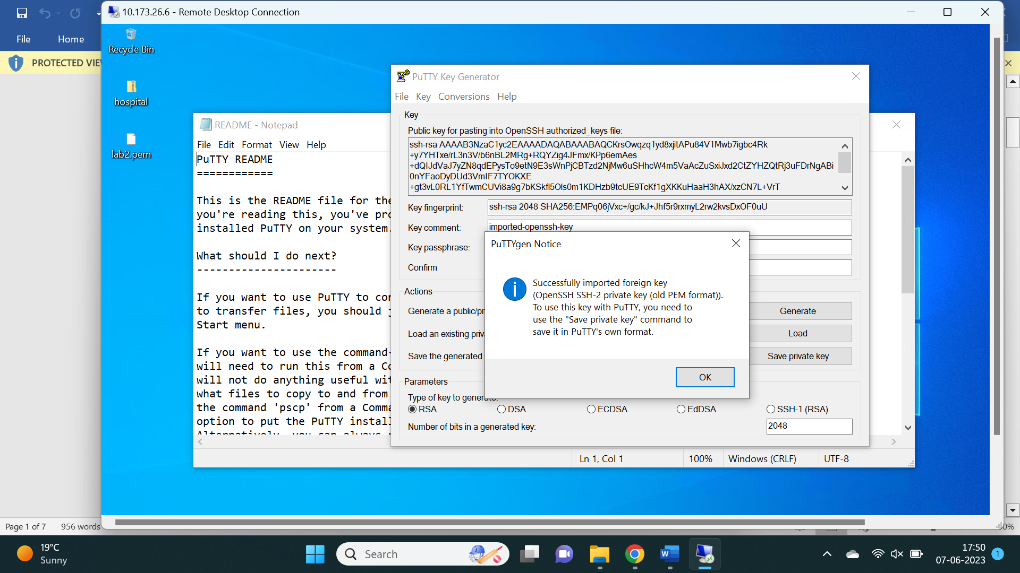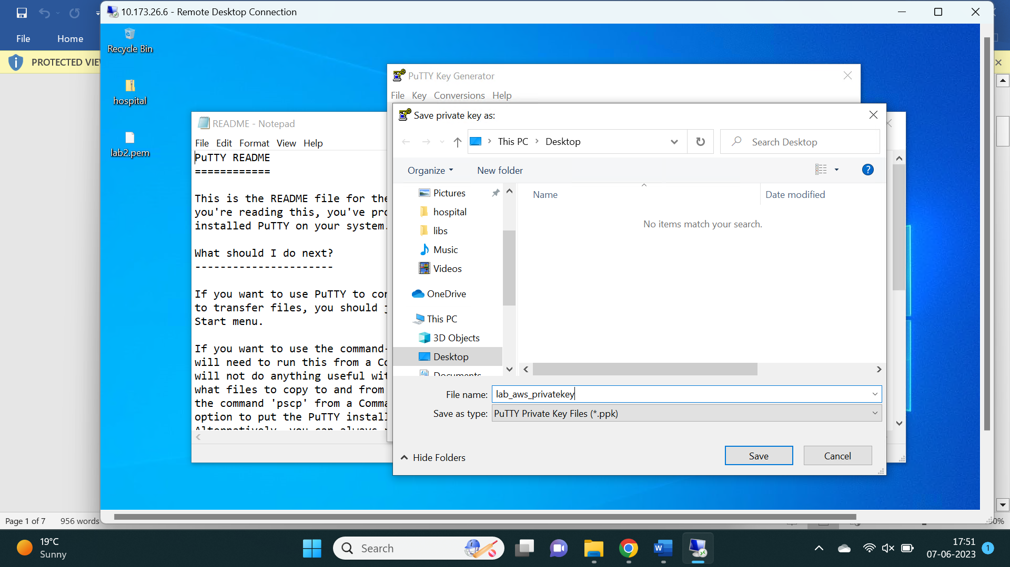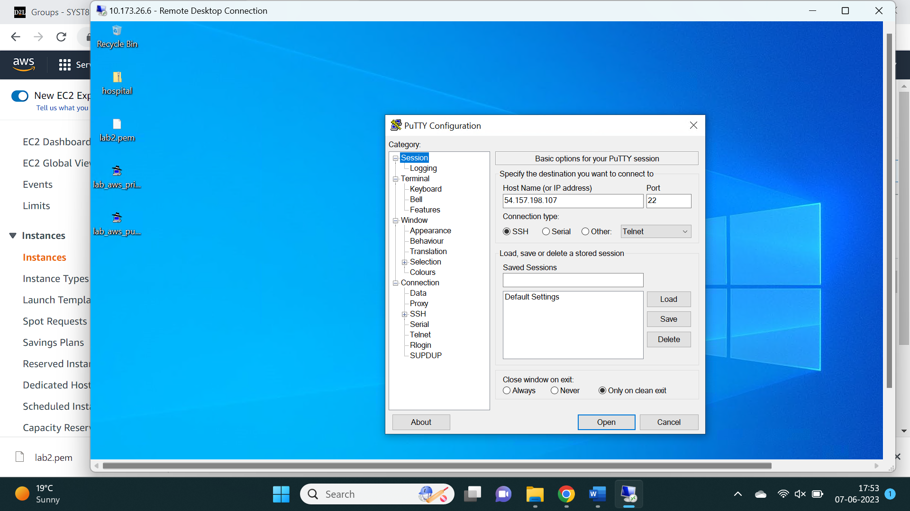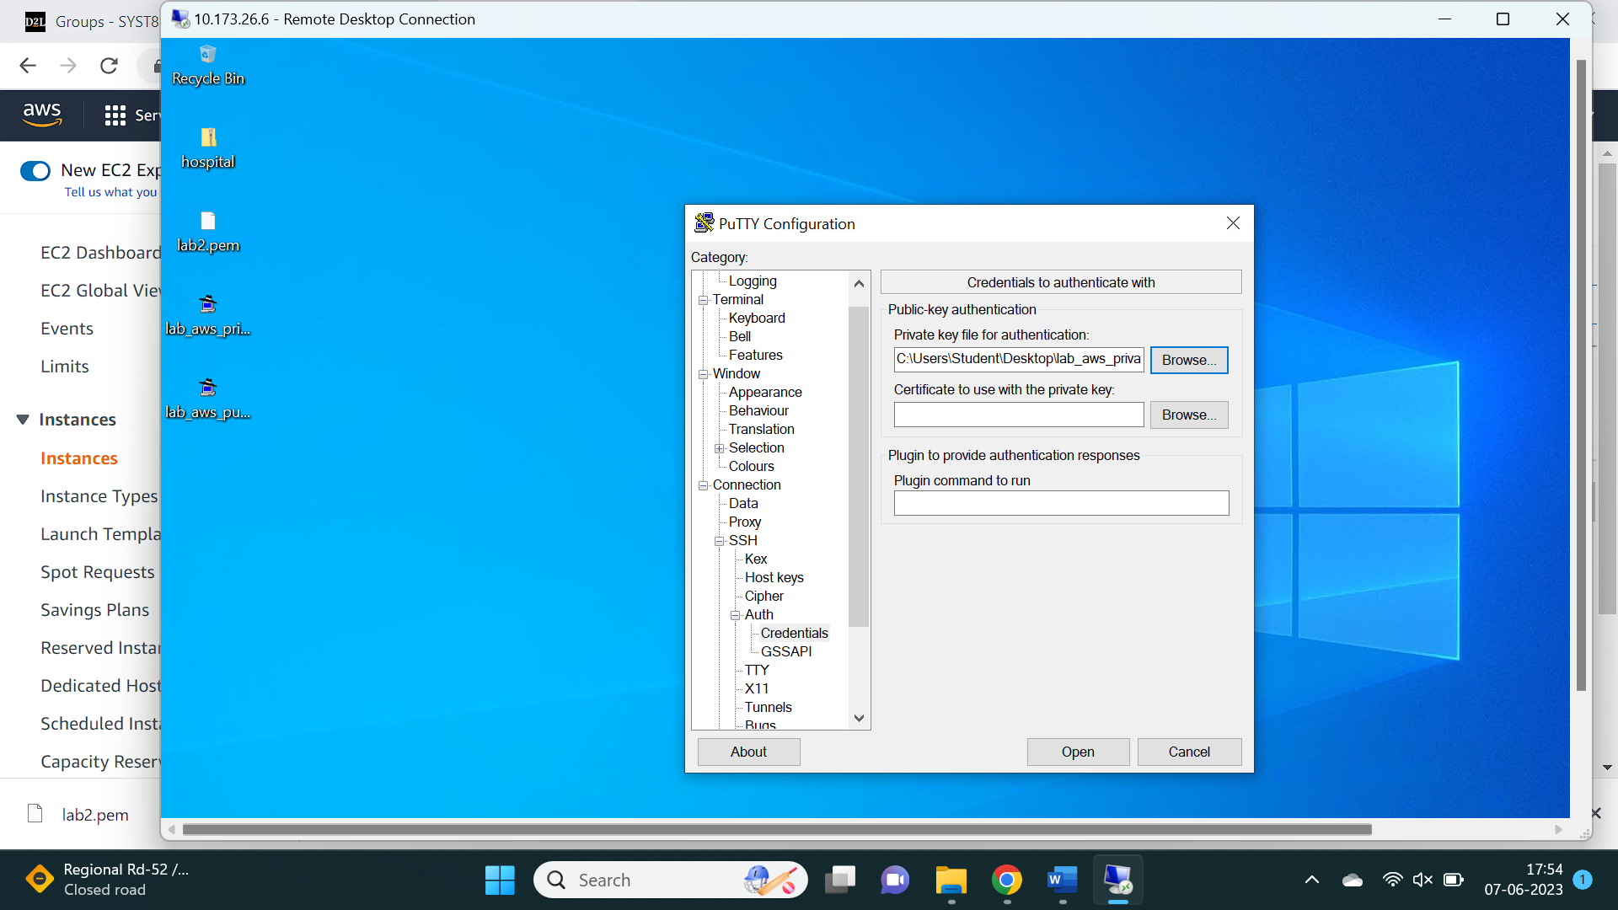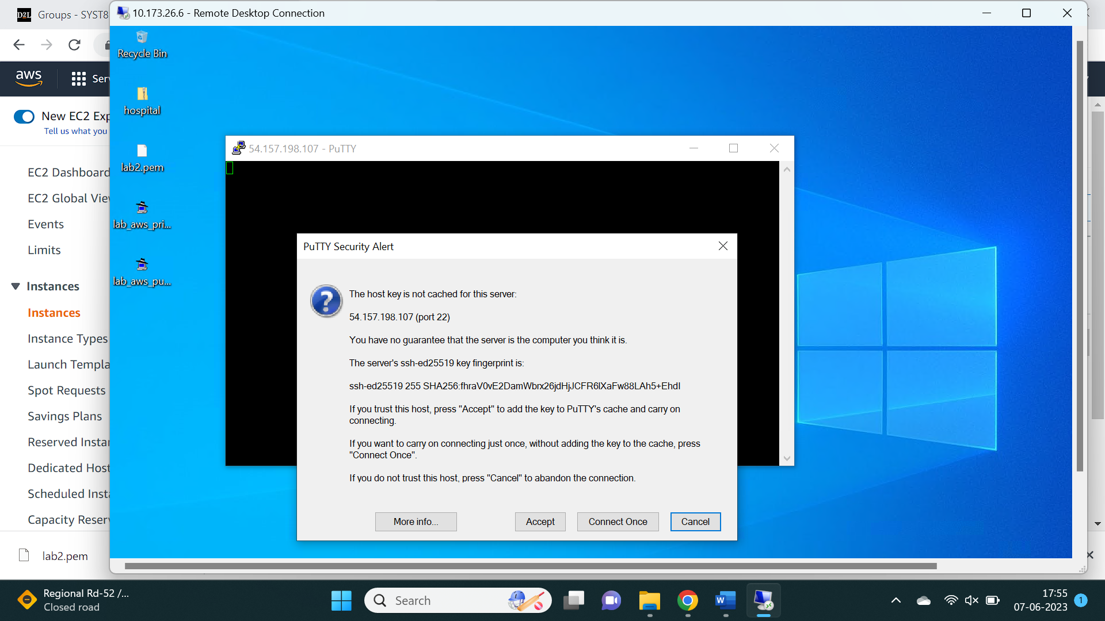

Task 3 : Installation of pre-requisites on Linux machine: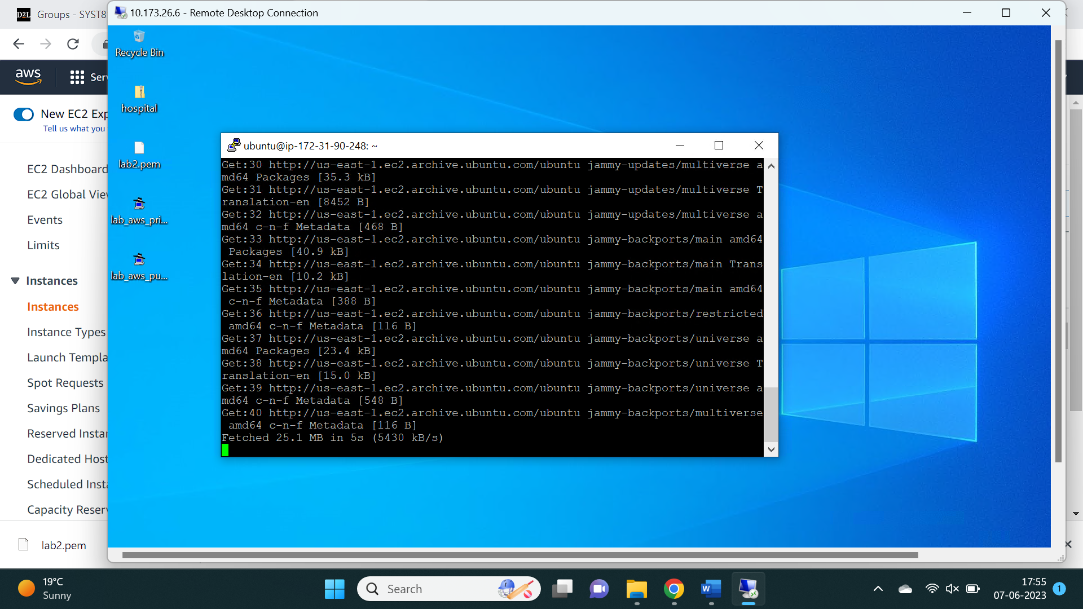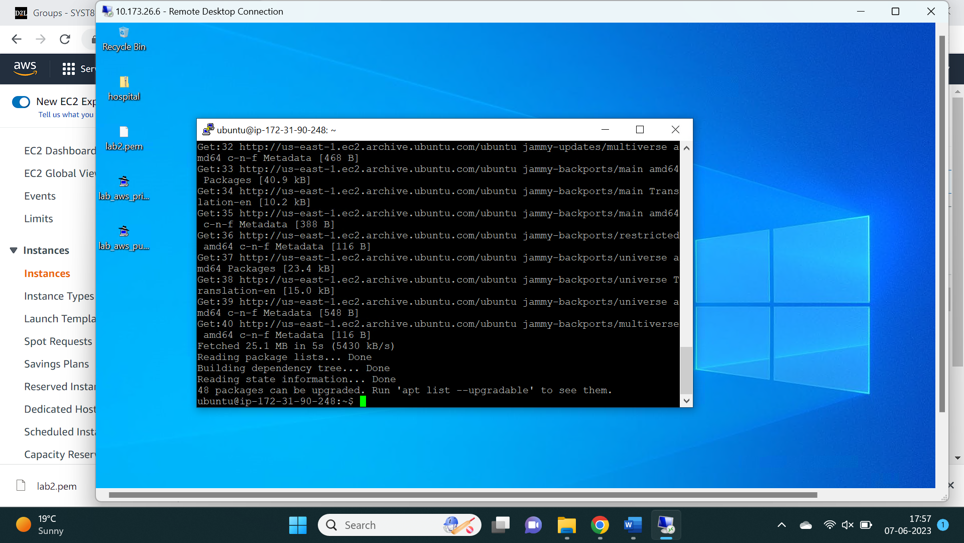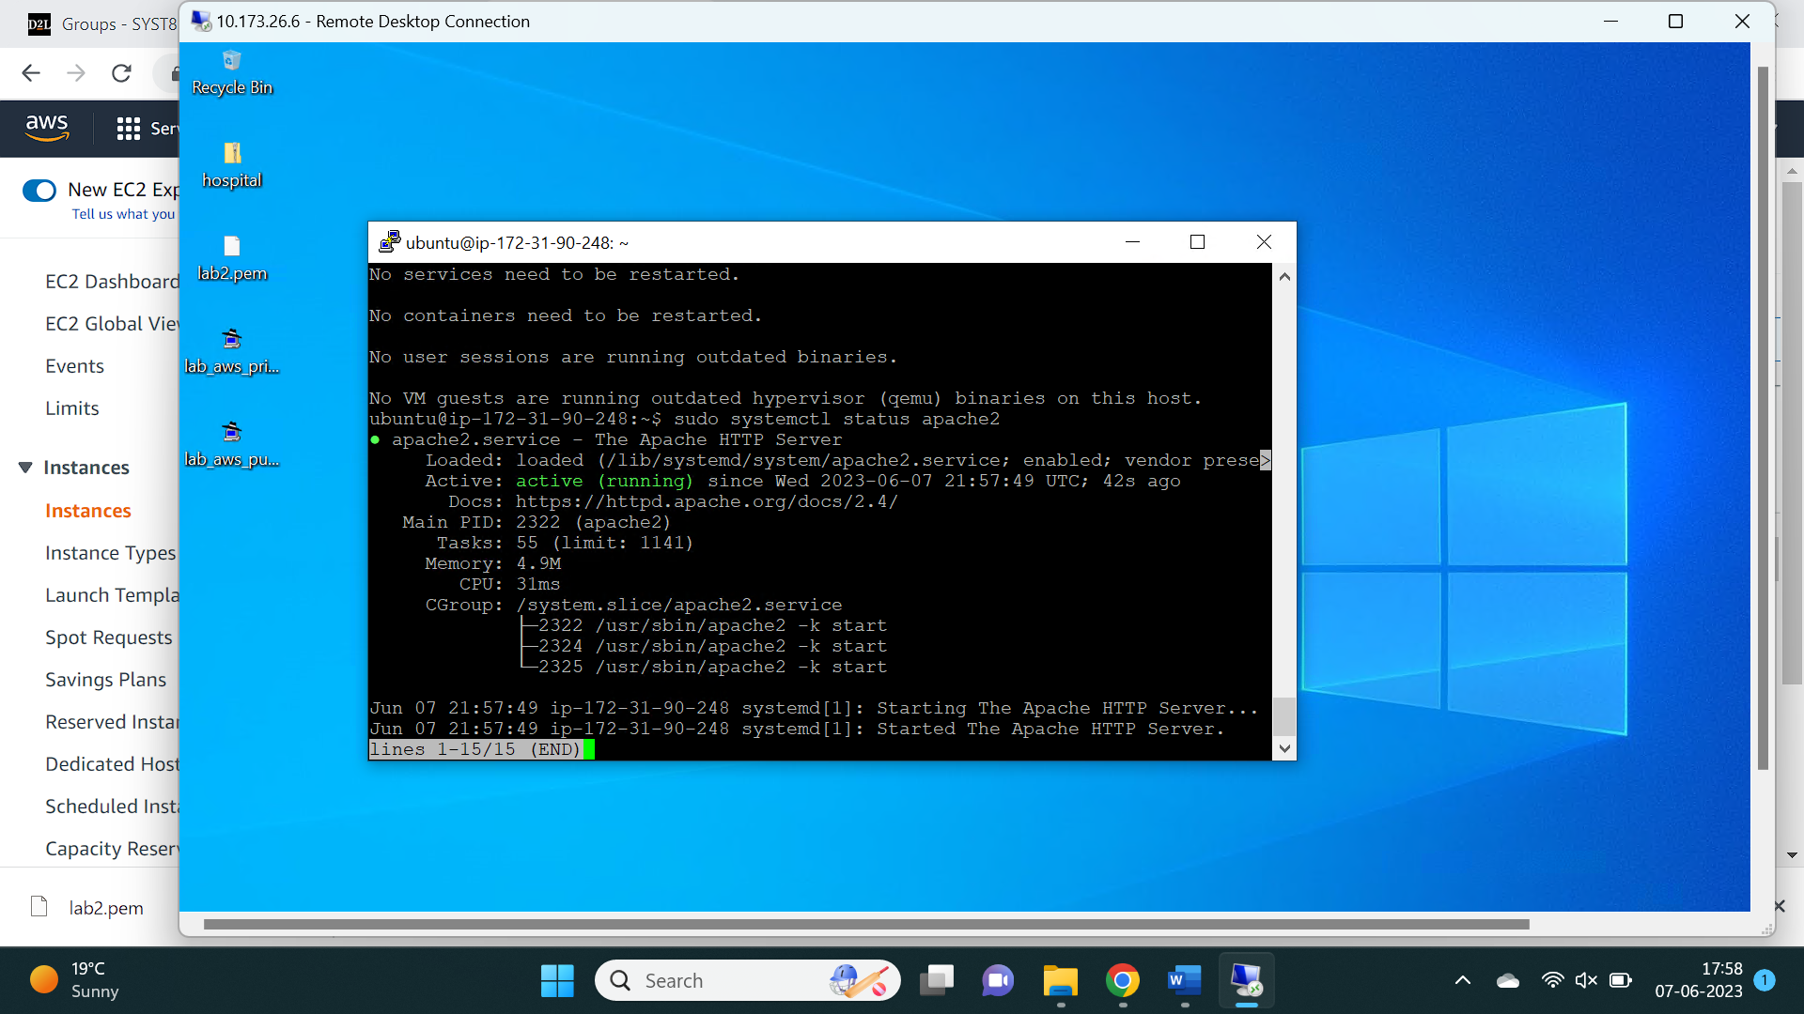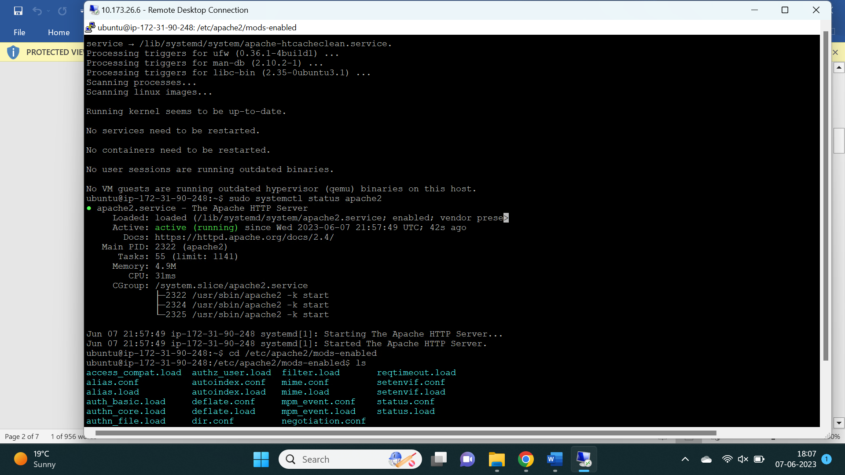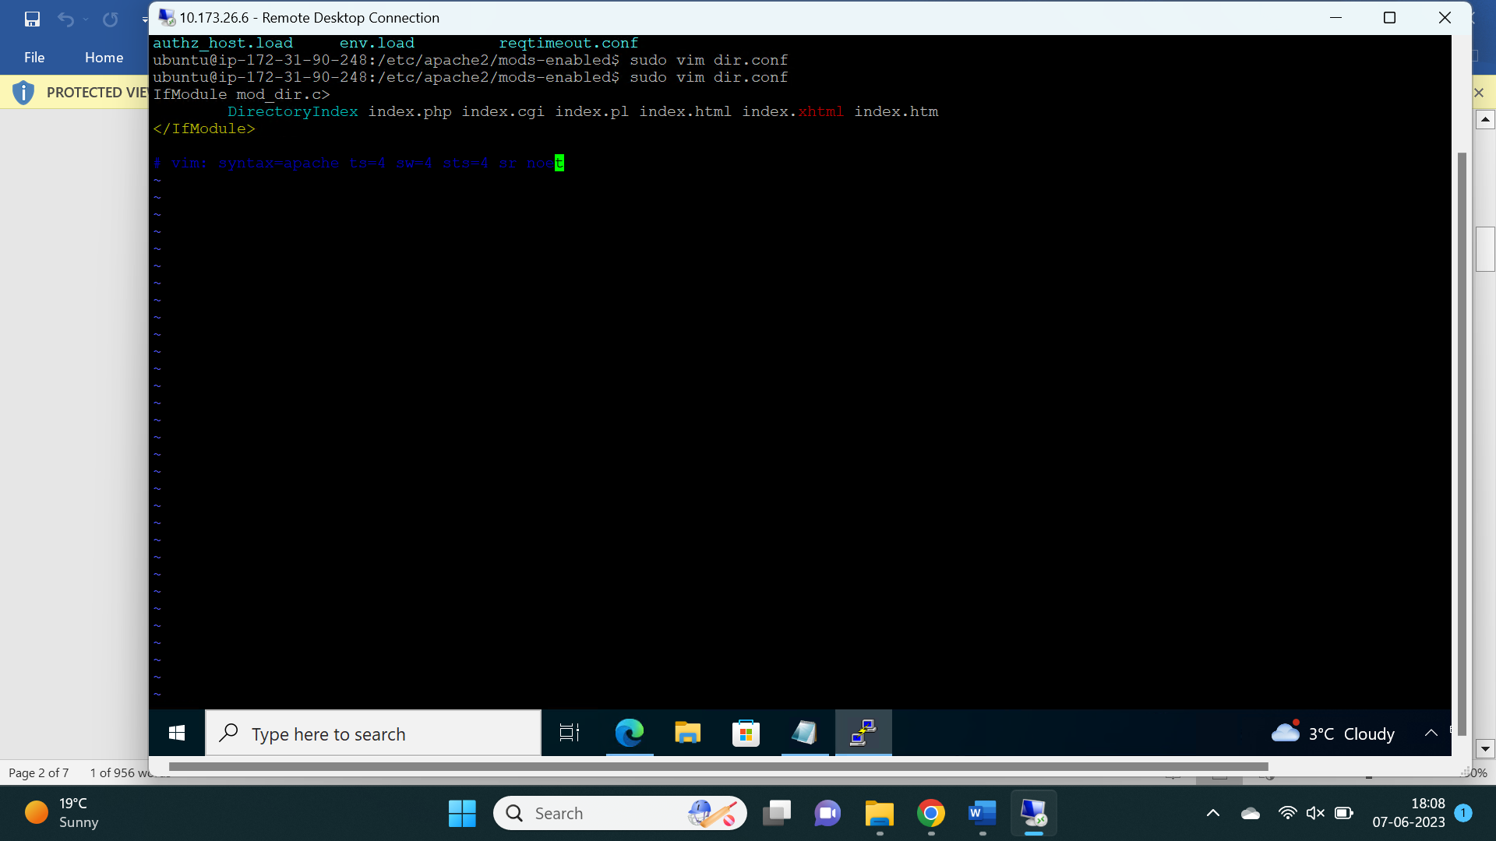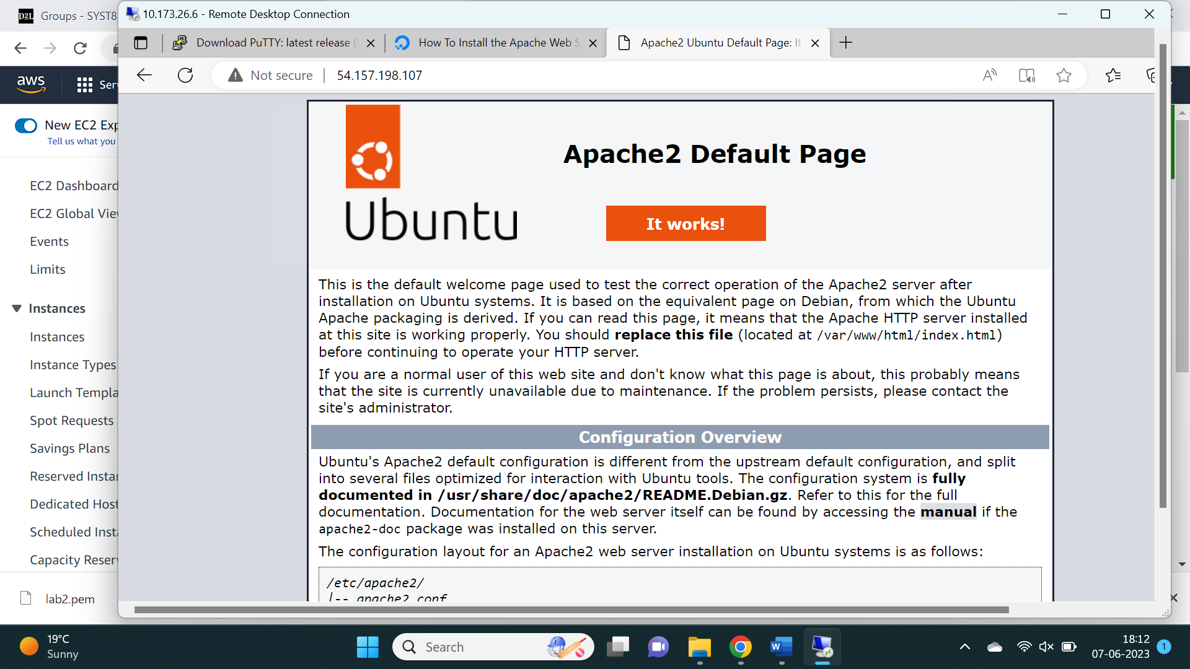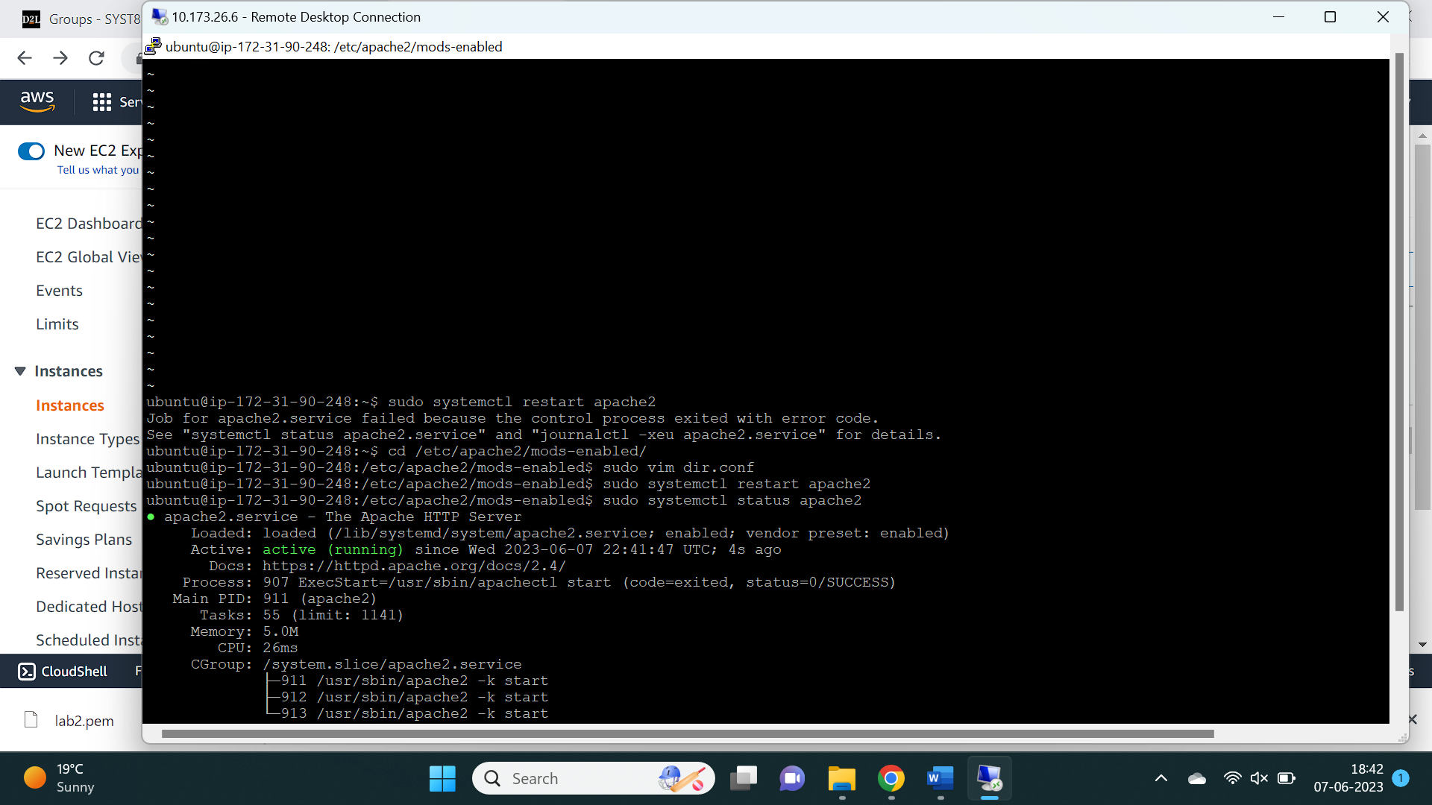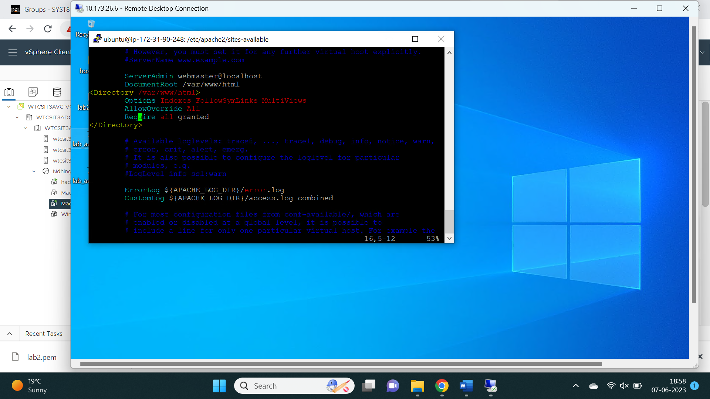

Task 4 : Creation of new RDS Database

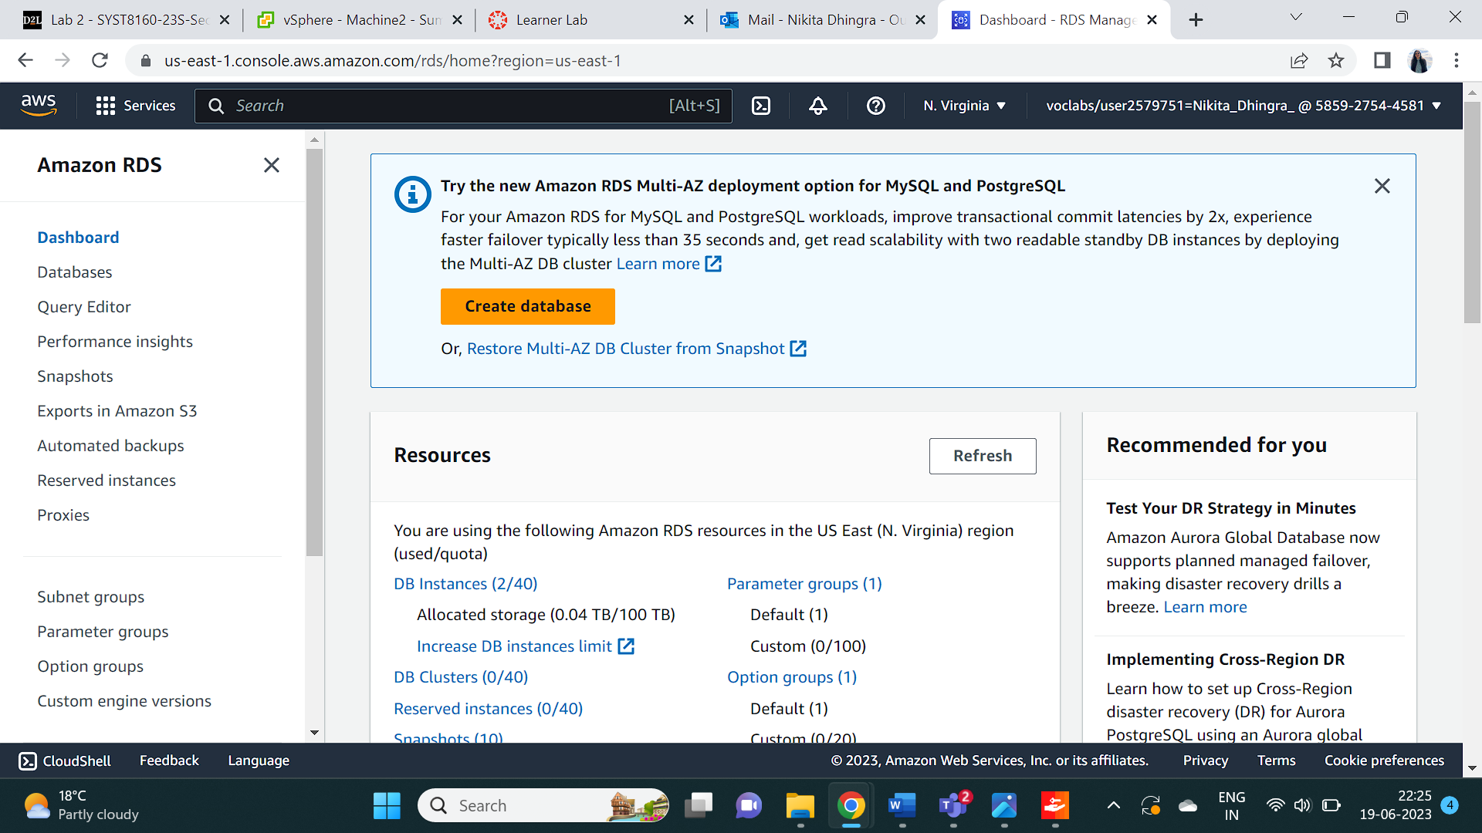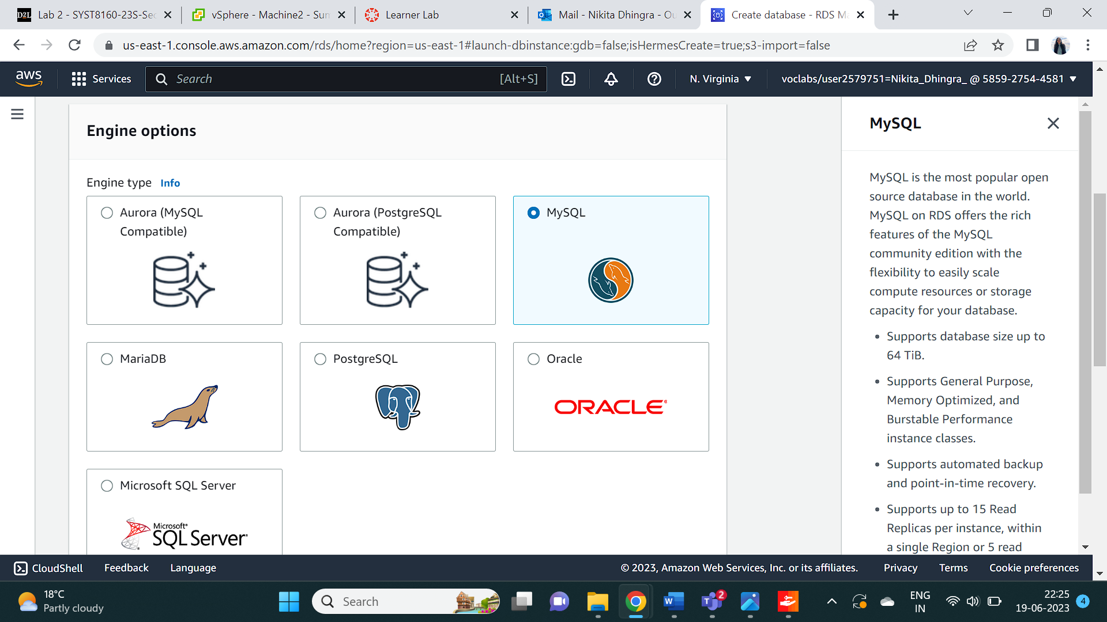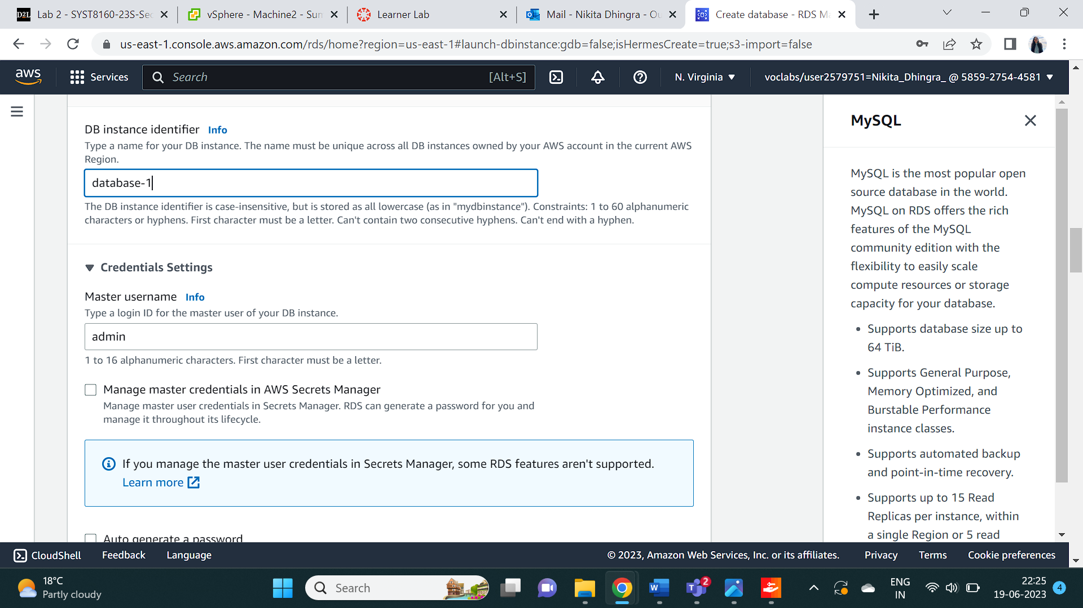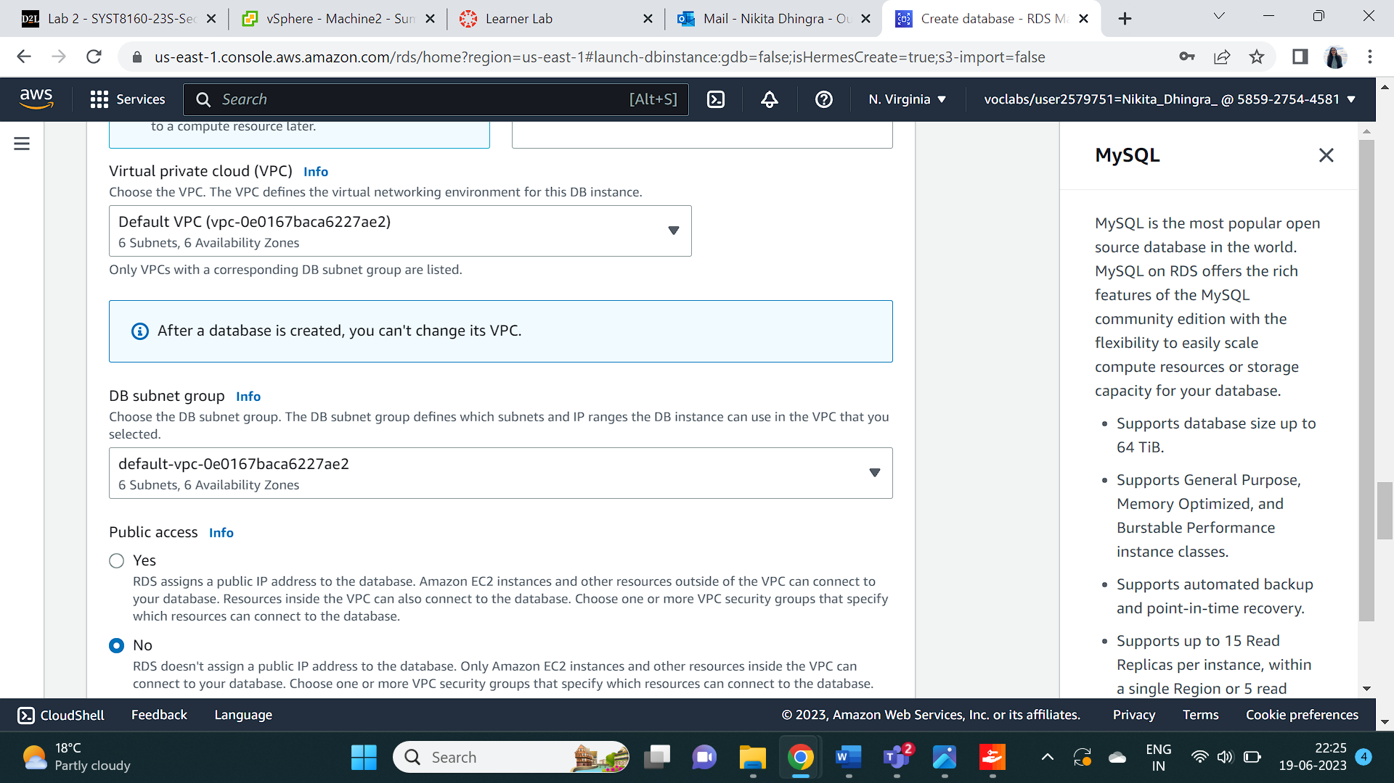

Task 5 : Installing FileZilla on VM instance and putting apps in the machine:

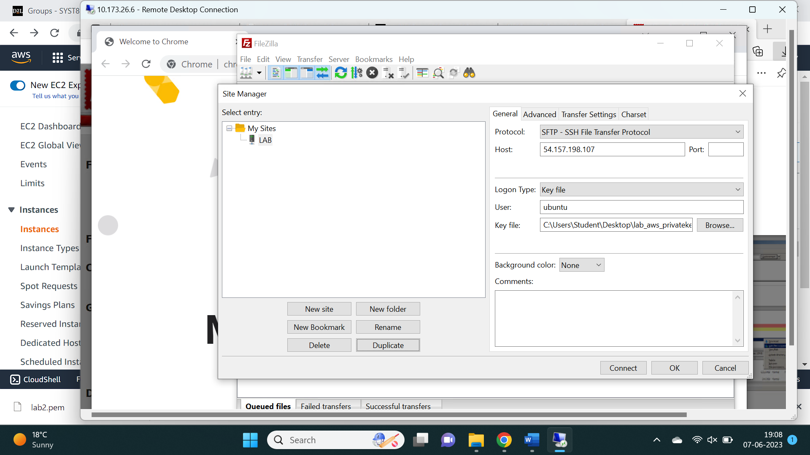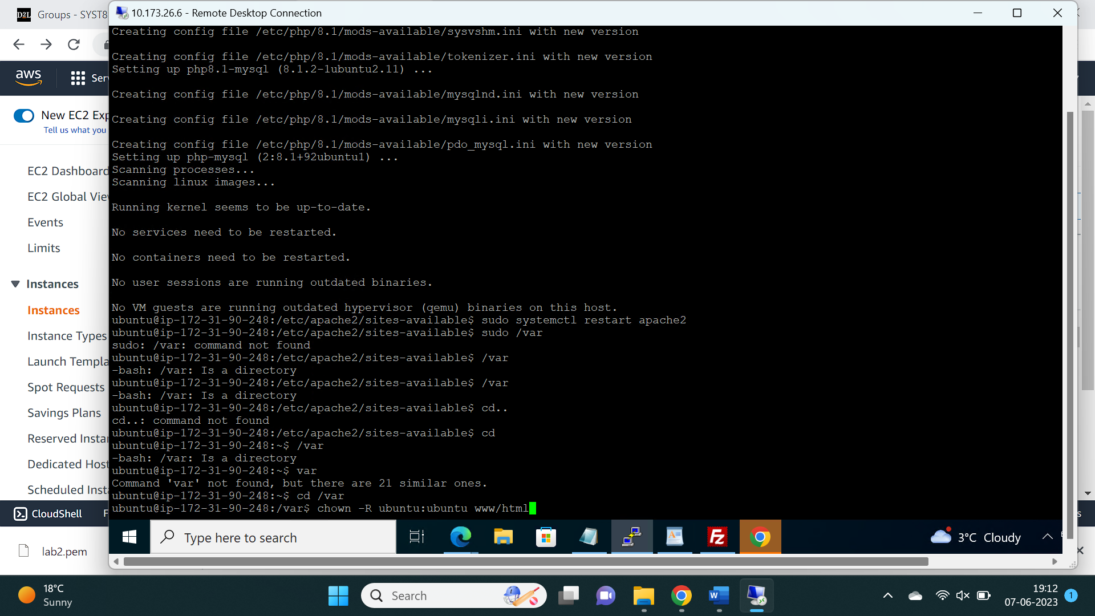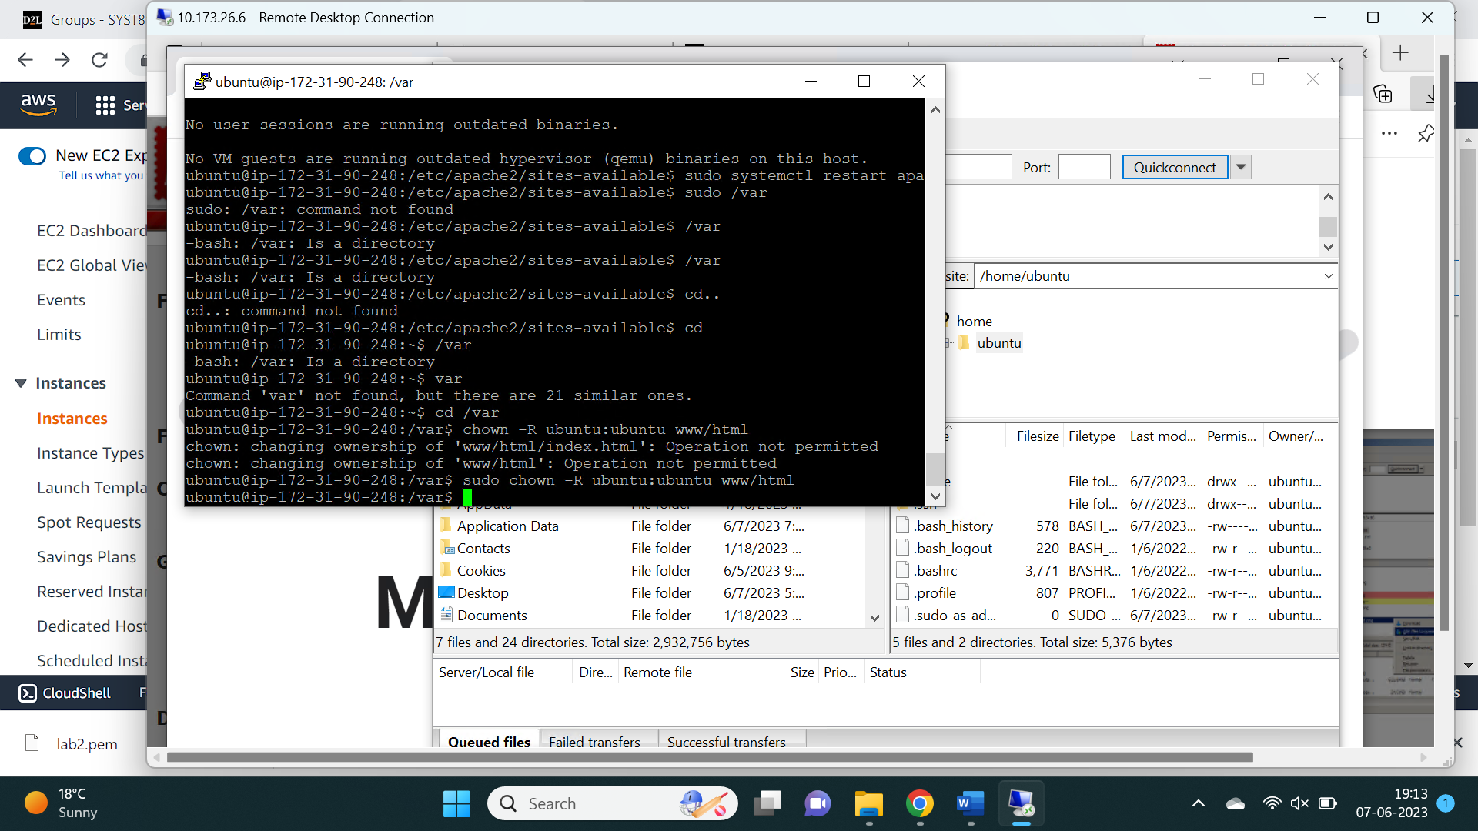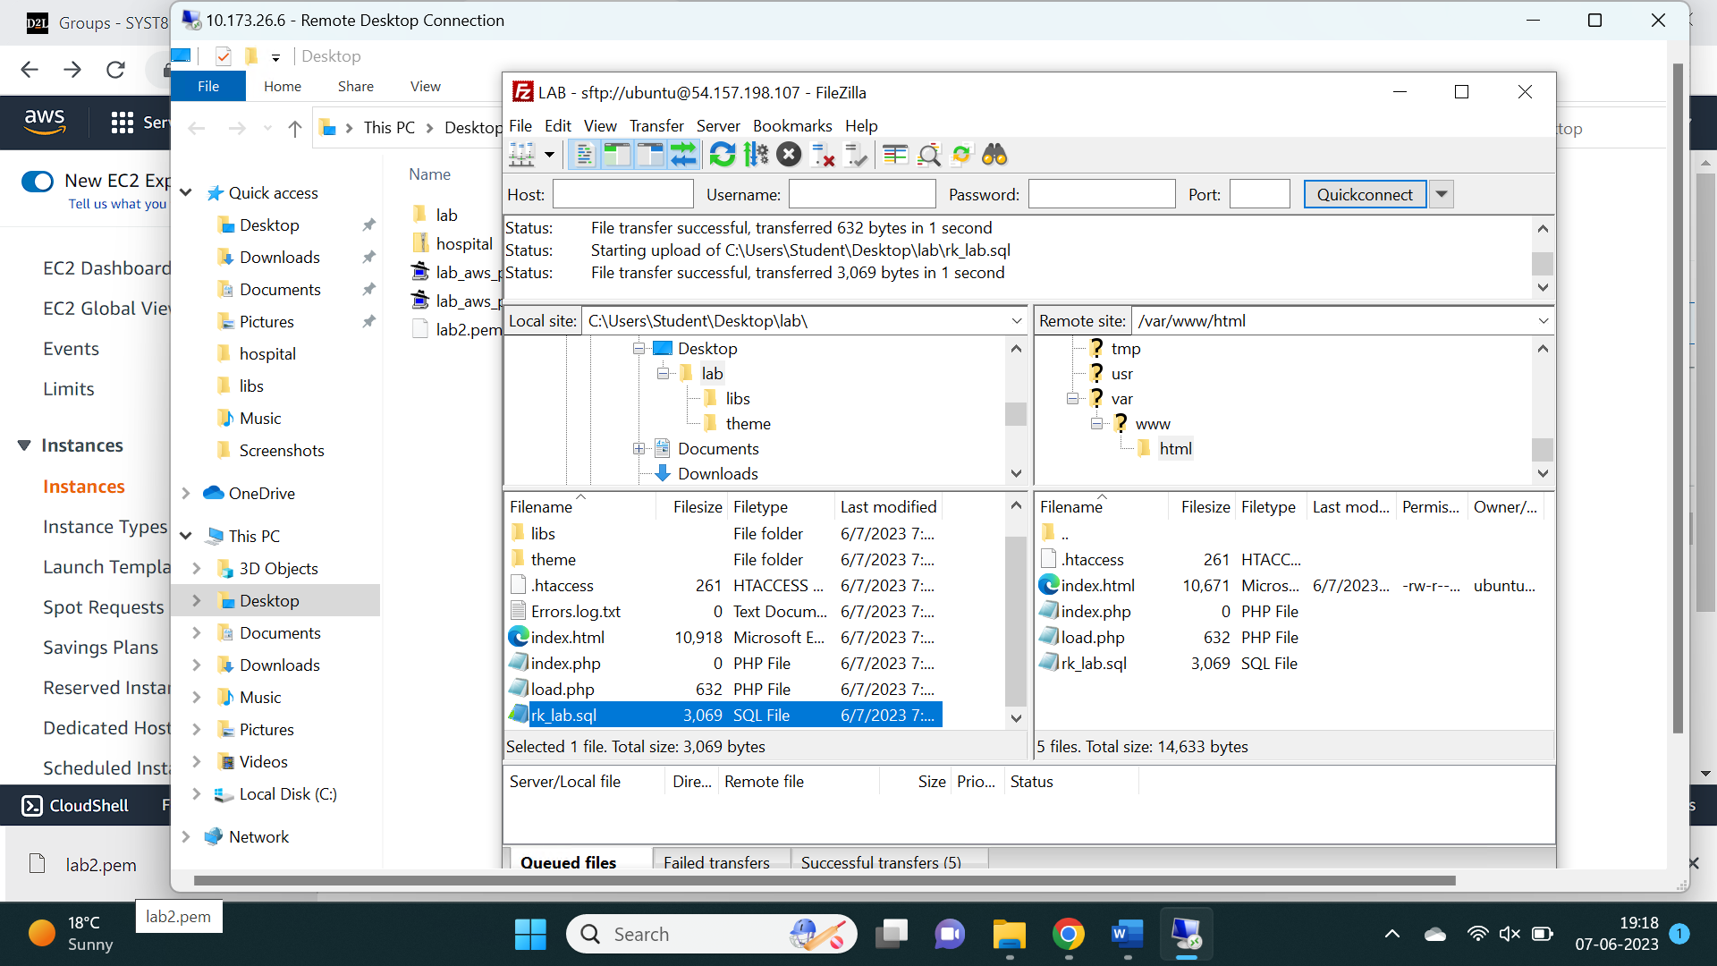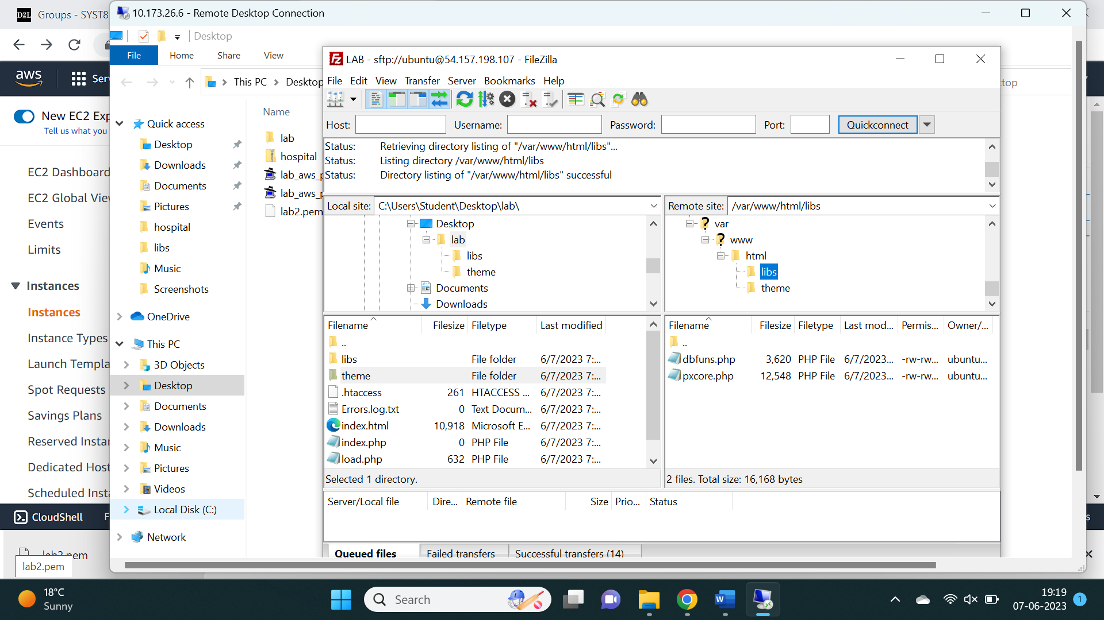

Task 6 : Integration with the another Hospital application:



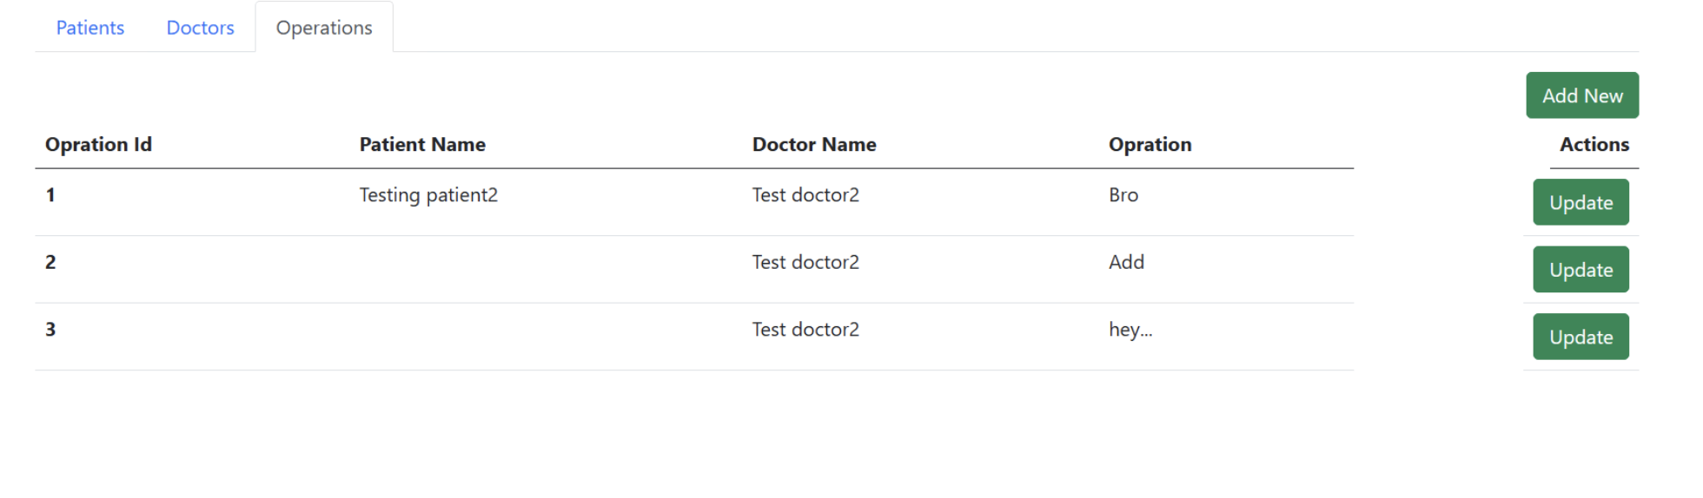

## Reflection

This lab activity provided me with proper knowledge regarding deployment of another application on an AWS Linux machine, installation of prerequisites, building a new database, and connection of the Hospital application which was created in the lab activity 1.